Y G Salon offers Bridal Makeup Henna Services

**BRIDAL HENNA** DESIGN

**SERVICE** STARTS AT

FULL **MAKEUP** SERVICE

**AVAILABLE** FOR

**BRIDAL** HAIR STYLE

**SERVICE AVAILABLE** FOR

**EYE MAKEUP** SERVICE

**AVAILABLE** FOR

**PARTY MAKEUP AVAILABLE** FOR

LIGHT **MAKEUP** FOR

1\ED

349

1\ED

349

1\ED

149

1\ED

149

1\ED

149

1\ED

•

- ,)> *;R,-OJJ*

*a·i* l,).·;.-J

u-4 u->-9;-saJ..I s-L..:,Jl

JR*.z*·*v*·*-*·*:*·-' Q..,.,Q;... *,*.*-.*.*\.*.*.Sl..o* ..i.w

**HENNA** FOR HANDS STARTS AT

99

1\ED

##### 30

*.TI--;.*

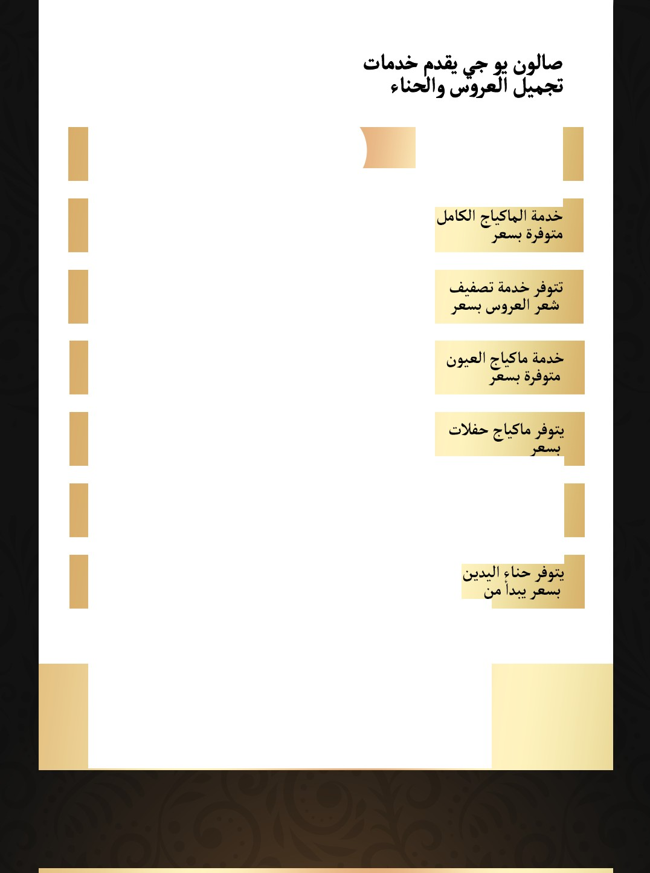

CallUs:**0522381623** / **624** / **625**

Visit [www.ygsalon.ae](http://www.ygsalon.ae/)for more information and to book an appointment

Brc,,v Bar Services

LAMINATION

1\ED

99

1\ED

TINTING AND COLORING

59

1\ED

HENNA TINT 59

*YI..>***iie•...:,**

•

SHAPING AND THREADING

Facial Services

EYE TREATMENT

NATURE GOLD FACIAL TREATMENT

**DEEP** CLEAN FACIAL

**CLEANSING FACIAL**

**BRIGHTENING TREATMENT**

**NORMAL FACE BLEACH OLIVIA** I **GOLD**

1\ED

# 35

1\ED

105

1\ED

### 75

1\ED

## 69

1\ED

59

1\ED

59

1\ED

##### 45

b .***.***.***.***·***:>-9***

*S* + *_* *U•¼*·*:.J*·*Z*'·*.*

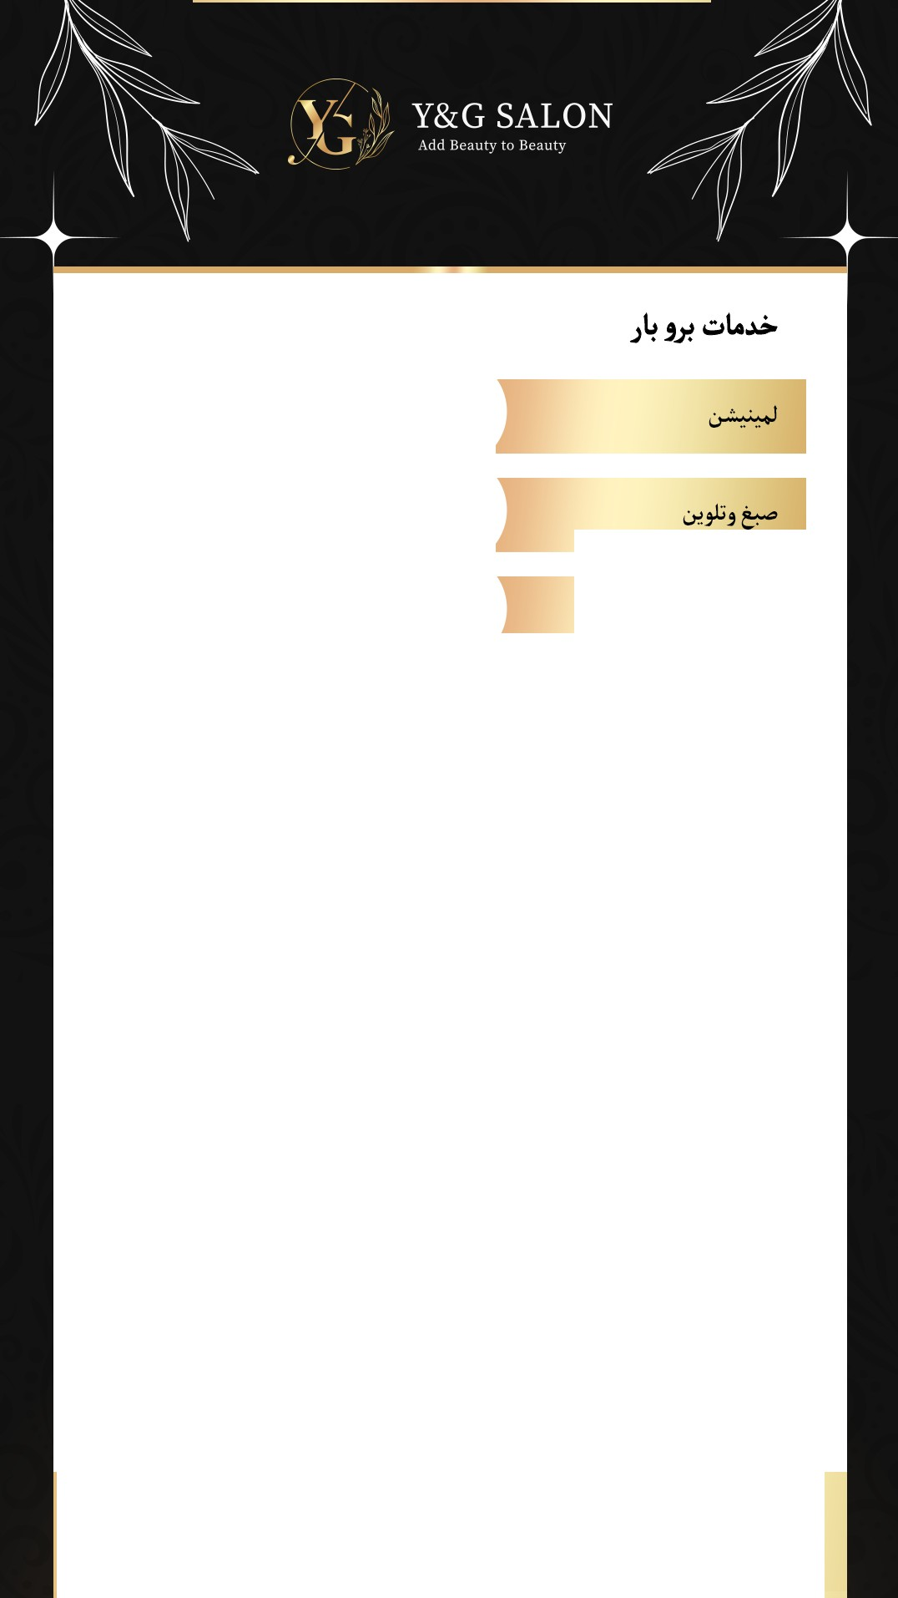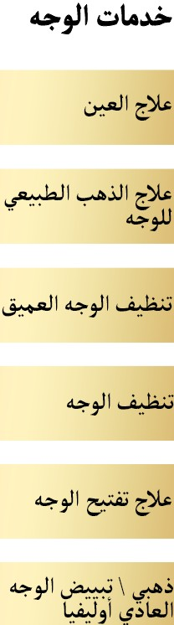

**CallUs:0522381623** / **624** / **625**

Visit [**www.ygsalon.ae**](http://www.ygsalon.ae/)for more information and to book an appointment

Fc,c,t Spa Services

FRENCH GEL PEDICURE

FRENCH GEL MANICURE

GEL MANICURE

GEL PEDICURE

FRENCH MANICURE

FRENCH PEDICURE

1\ED

169

1\ED

149

1\ED

199

1\ED

129

1\ED

120

1\ED

130

**LUXURY HAND TREATMENT NORMAL POLISH**

1\ED

149

**LUXURY FOOT TREATMENT NORMAL POLISH**

1\ED

169

**MINI POLISH (KIDS}**

**GEL REMOVAL**

1\ED

##### 59

1\ED

##### 50

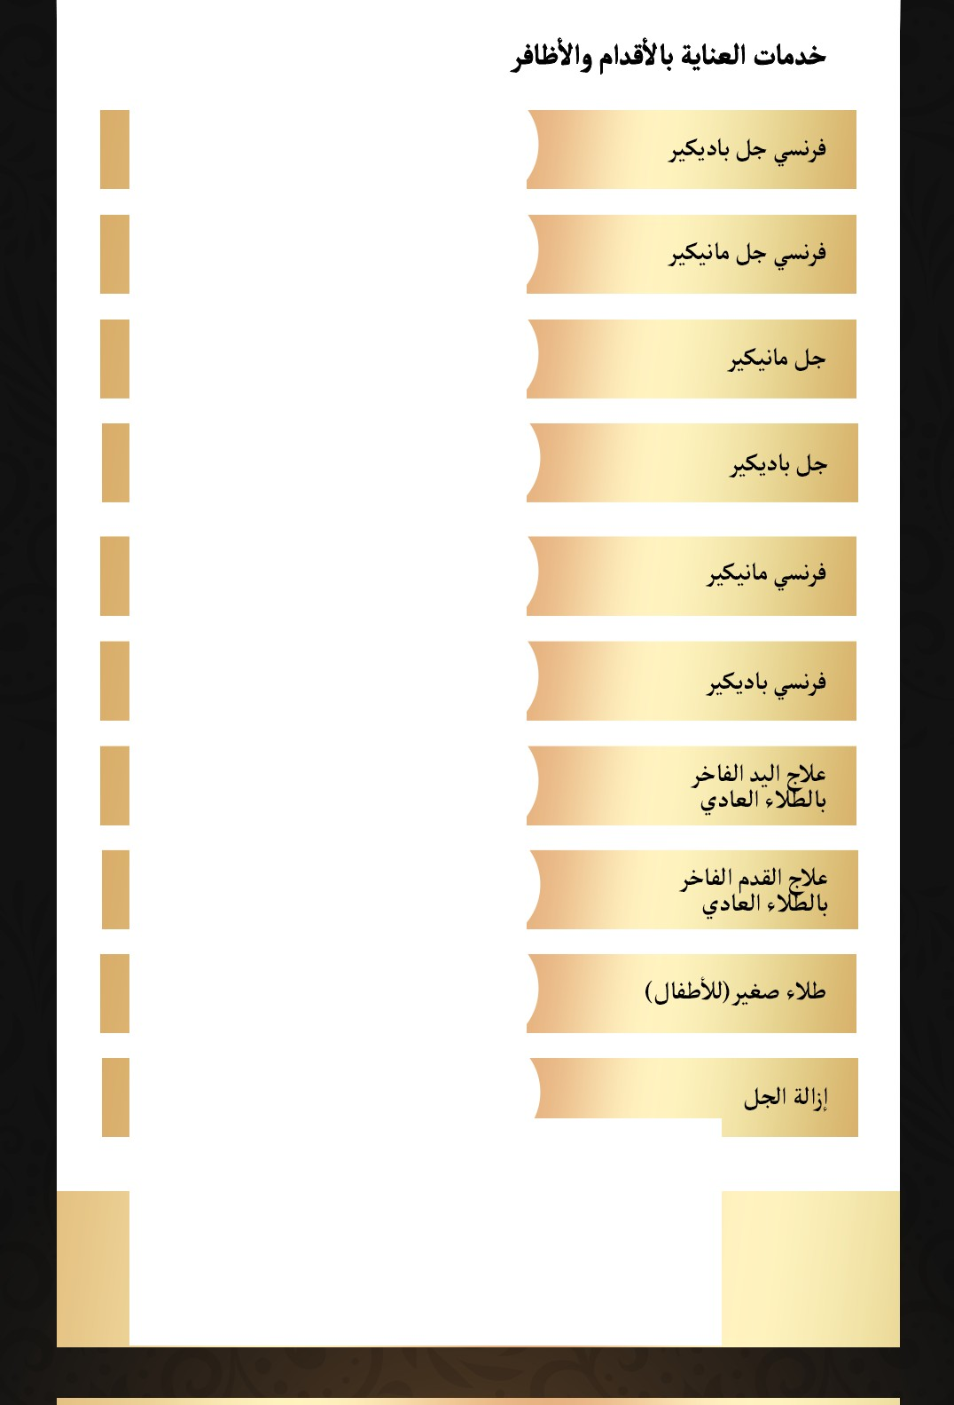

**CallUs:0522381623** / **624** / **625**

Visit [**www.ygsalon.ae**](http://www.ygsalon.ae/)for more information and to book an appointment

Fc,c,t Spa Services

**DELUXE MANICURE (NORMAL POLISH}**

**DELUXE PEDICURE (NORMAL POLISH}**

1\ED

109

1\ED

99

**LITTLE PRINCESS PEDICURE (NORMAL POLISH}**

**LITTLE PRINCESS MANICURE (NORMAL POLISH}**

**DELUXE COMBO (MANI** +**PEDI}**

1\ED

49

1\ED

29

1\ED

99

**SIGNATURE Y&G COMBO**

1\ED

149

**SHAPE AND POLISH FEET**

1\ED

50

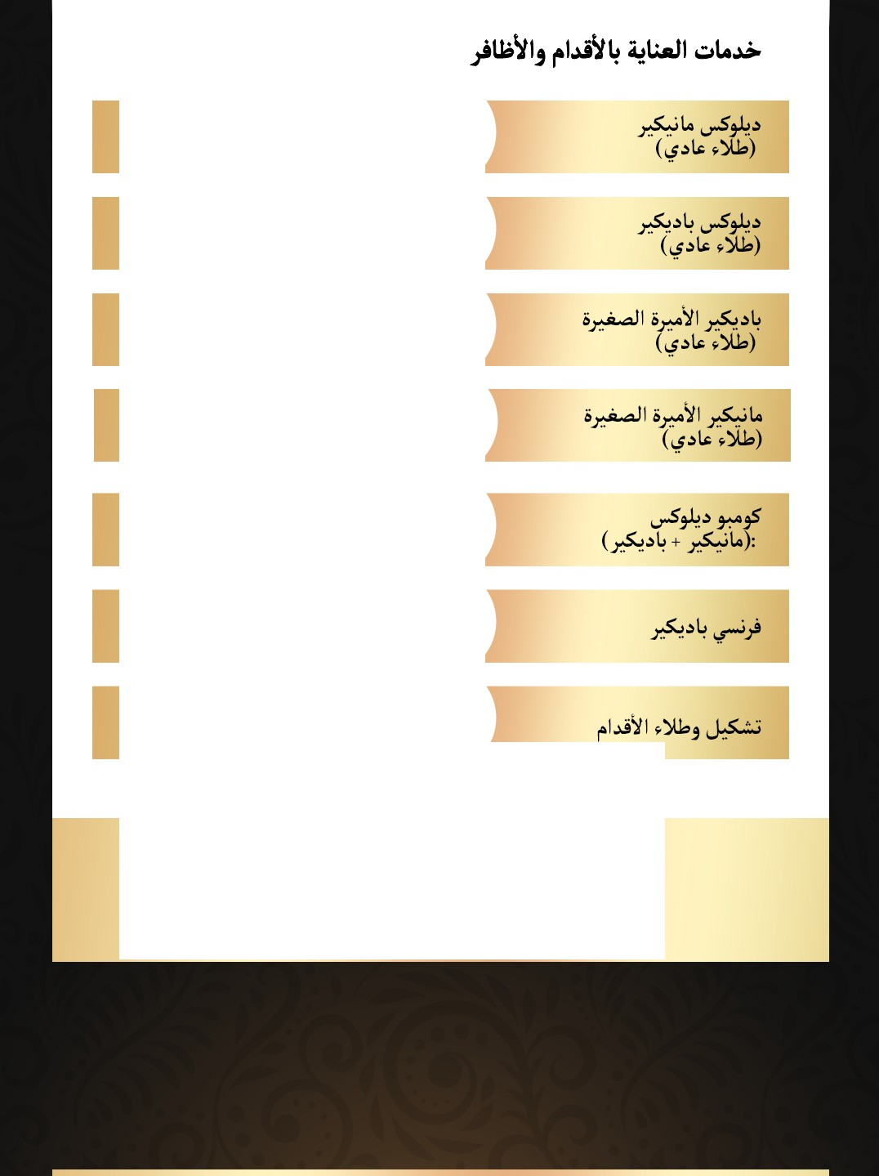

**CallUs:0522381623** / **624** / **625**

Visit [**www.ygsalon.ae**](http://www.ygsalon.ae/)for more information and to book an appointment

Hair Services

HAIRCUT WITH NORMAL DRY

BLOW DRY (CURL & WAVY}

1\ED

## 69

1\ED

80

KIDS HAIR CUT (12Y/O}:

HAIR REBONDING

**BRAIDS** STARTING

**STYLING HAIRCUT**

**BLOW DRY ONLY**

**CUT&TRIM**

**HAIR NUTRITION**

**EXPRESS SCALP PURIFYING**

1\ED

###### 29

1\ED

###### 249

1\ED

###### 49

1\ED

###### 59

1\ED

###### 59

1\ED

###### 49

1\ED

149

1\ED

149

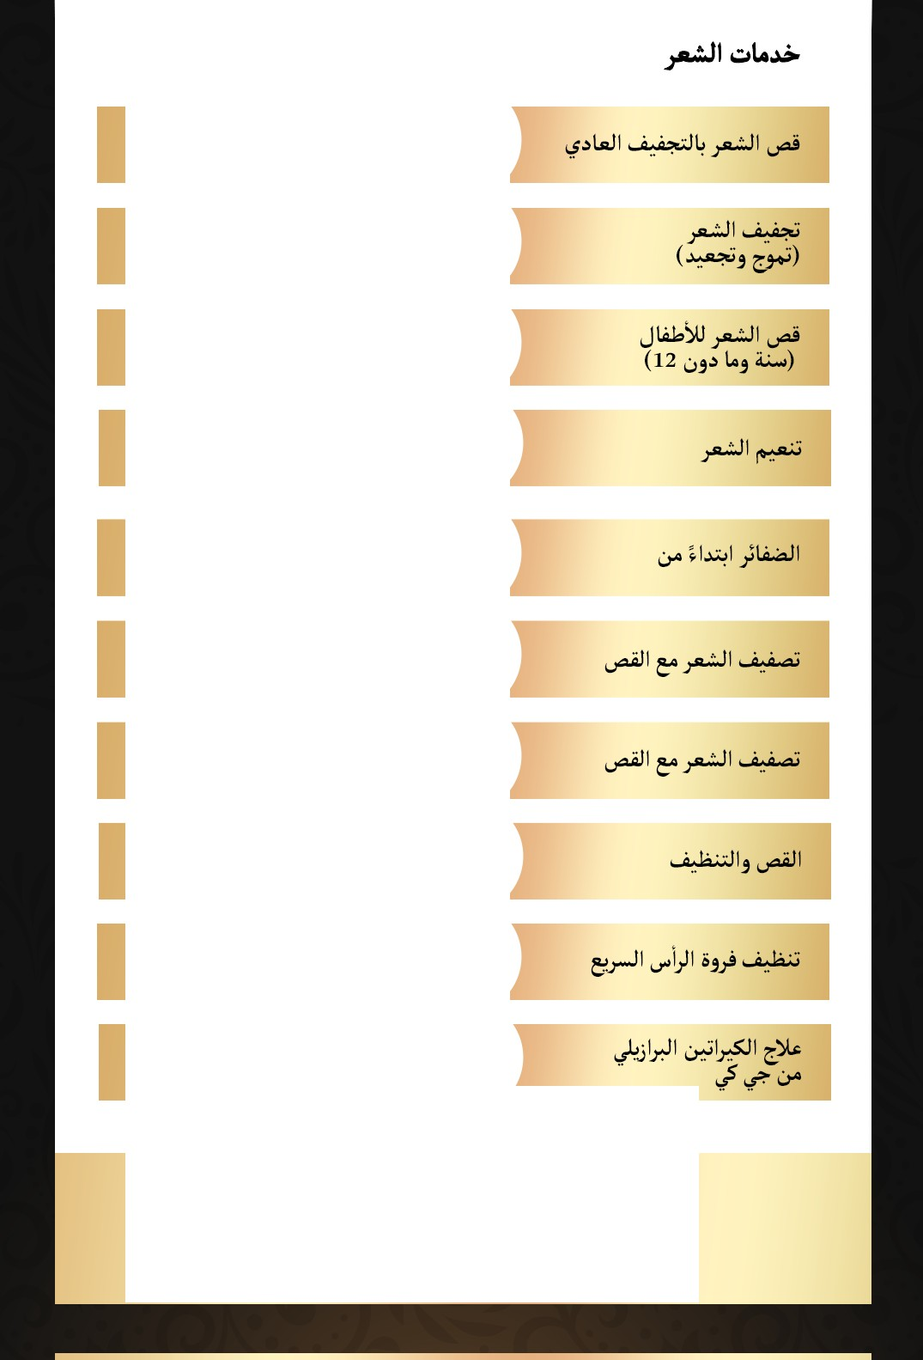

**CallUs:0522381623** / **624** / **625**

Visit [**www.ygsalon.ae**](http://www.ygsalon.ae/)for more information and to book an appointment

Hair Services

GK BRAZILIAN KERATIN TREATMENT

HAIR BOTOX/PROTEIN TREATMENT

Lashes Services

1\ED

349

CLASSIC LASHES

RUSSIAN VOLUME

(4-5)0

2DLASHES

1\ED

149

1\ED

249

1\ED

109

;.i.-**.**..**S**..**:**.........",.,1J.'w,.. • **t4**

1\ED

FALSE LASHES

99

**EYELASH** LIFTING

**EYELASHES** REFILL CLASSIC23D

**REMOVAL** ONLY

1\ED

149

1\ED

199

1\ED

###### 89

**EYEBROWS EYELASHES**

TINT &

**TINT**

1\ED

199

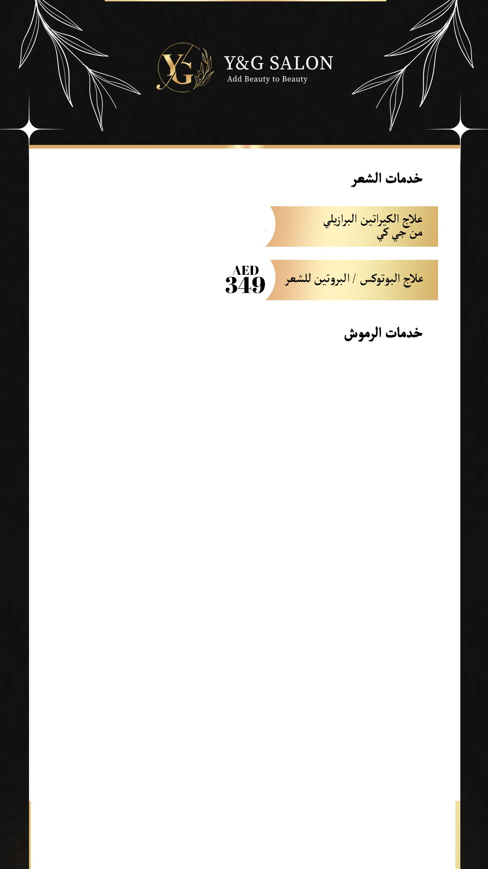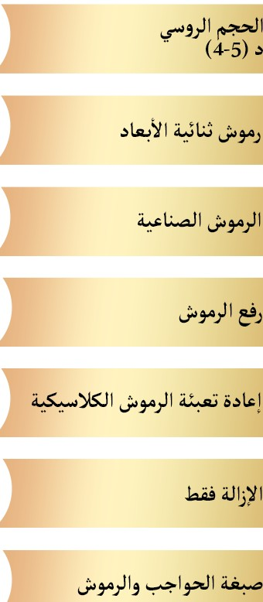

**CallUs:0522381623** / **624** / **625**

Visit [**www.ygsalon.ae**](http://www.ygsalon.ae/)for more information and to book an appointment

We c,tfer a rangec,f prc,fessic,nal1nassage services at YG Salc,n. Here's a list c,f c,ur services and prices

i. u,4 as,,"!" r-'i;YG. *\.-j\.* a.Jli 41!

u,'Lo *J* li I l-,JI

**FOOT REFLEXOLOGY (30 MIN}**

**FEEL** & **HAND REFLEX (1 HR 30 MIN}**

**DEEP TISSUE MASSAGE (60 MIN}**

**SWEDISH MASSAGE (60 MIN}**

SIGNATURE MASSAGE (60 **MIN}**

HOT STONE MASSAGE (30-60 MIN}

**INDIAN HEAD MASSAGE (30 MIN}**

**FULL BODY CARE MASSAGE (30 MIN}**

**FULL BODY POLISH**

**FULL BODY BLEACH**

1\ED

## 249

1\ED

190

1\ED

## 249

1\ED

## 299

1\ED

##### 320

1\ED

##### 350

1\ED

## 99

1\ED

## 99

1\ED

##### 95

1\ED

##### 95

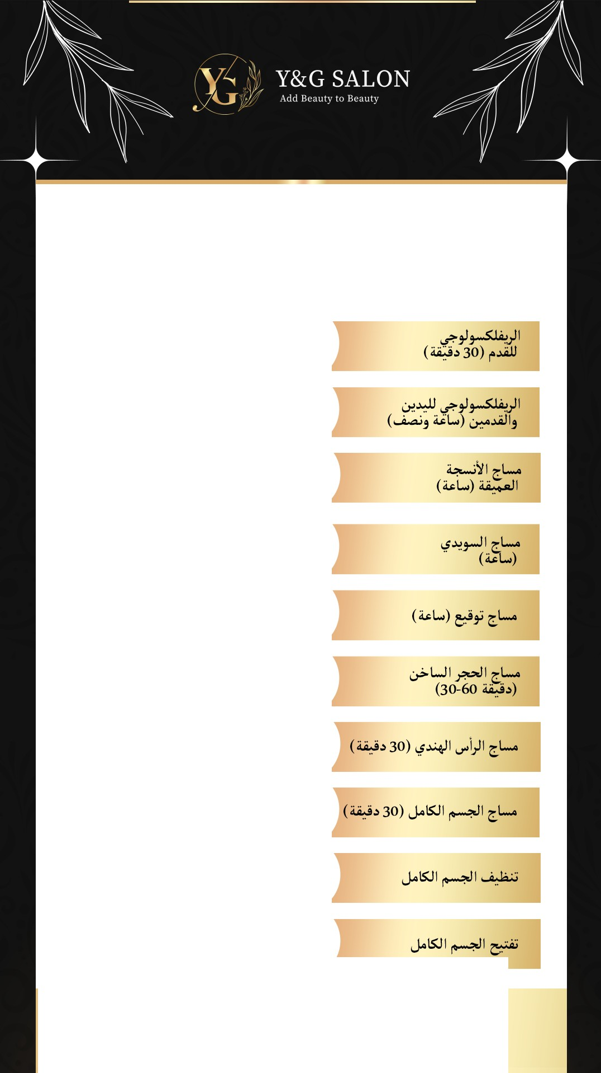

**CallUs:0522381623** / **624** / **625**

Visit [www.ygsalon.ae](http://www.ygsalon.ae/)for more information and to book an appointment

Microbla,ling a,n,I Lip lllt1shing/Micro-pigmentation (SPMU)

,JI . ,1.:-,q-l,,_JI J;,'?'U *I* i all I ½+ii' (SPMU)

MICROBLADING 1\ED

349

(SINGLE SESSION}

RETOUCH MICROBLADING 1\ED

349

(AFTER ONE SESSION}

'½-91...;:,)'1'-:- l

(i>J.>l-9

I

**.>A!)**

LIP BLUSHING/ MICRO - 1\ED

449

PIGMENTATION

RE-TOUCH 1\ED

159

(LIP SHADING}

Nail Services Package

HARD GEL OVERLAV

NAIL EXTENSION REFILL

1\ED

180

1\ED

99

NAIL EXTENSION REMOVAL

1\ED

59

**REFILL FOR** LONG

**EXTENSIONS**

**REFILL FOR SHORT EXTENSIONS**

**NAIL EXTENSION** ( **GEL, ACRVGEL** & **POLVGEL}**

1\ED

###### 159

1\ED

99

1\ED

299

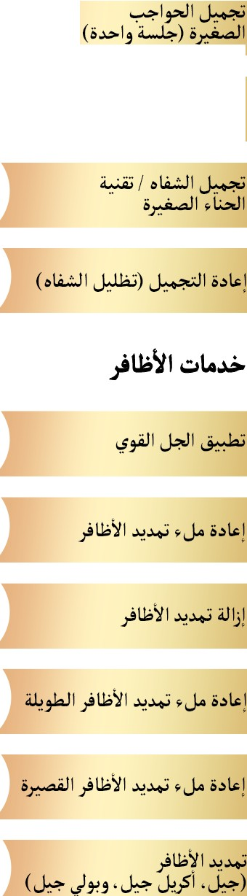

**CallUs:0522381623** / **624** / **625**

Visit [www.ygsalon.ae](http://www.ygsalon.ae/)for more information and to book an appointment

rrhreading Services

FOREHEAD THREADING

1\ED

EYEBROW AND UPPER LIP THREADING

IO

UPPER LIP THREADING

FULL FACE THREADING

FULL FACE THREADING+

**EYEBROWS**

1\ED

# 55

1\ED

# 25

1\ED

100

1\ED

# 125

**EYEBROW** THREADING

NOSE THREADING

CHIN THREADING

1\ED

# 35

1\ED

IO

1\ED

IO

"•ii b-

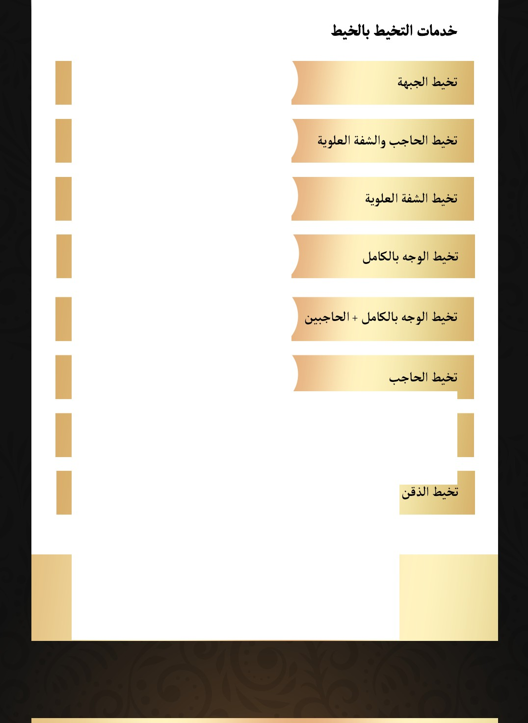

**CallUs:0522381623** / **624** / **625**

Visit [**www.ygsalon.ae**](http://www.ygsalon.ae/)for more information and to book an appointment

WAXING Services

LIP

1\ED

**CHIN**

IO

1\ED

**FACE**

1\ED

##### 59

IO

**FOREHEAD**

1\ED

##### 30

**BRAZILIAN WAX**

**HALFBACK WAX**

1\ED

## 69

1\ED

##### 45

**BACK WAX**

1\ED

##### 60

**CHEST WAX**

1\ED

## 40

**FULL BODY RICA WAX**

**FULL FACE RICA WAXING**

1\ED

249

1\ED

##### 59

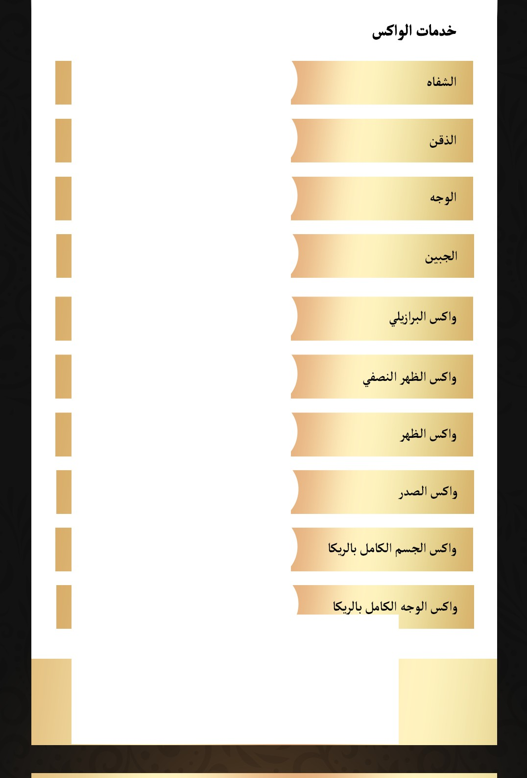

**CallUs:0522381623** / **624** / **625**

Visit [**www.ygsalon.ae**](http://www.ygsalon.ae/)for more information and to book an appointment

Skin Care Service

**NORMAL FACE BLEACH** /

**OLIVIA/GOL**

**DEEP CLEANING**

**HERBAL FACIAL**

**PAPAYA FACIAL**

**WINE FACIAL**

**MIX FRUIT FACIAL**

**NOSE THREADING**

**NATURE GOLD FACIAL**

1\ED

##### 30

1\ED

## 49

1\ED

80

1\ED

#### 70

1\ED

#### 70

1\ED

### 75

1\ED

### 75

1\ED

4

75 u.-.9--. b II '-:=-Ajj *j-1*l

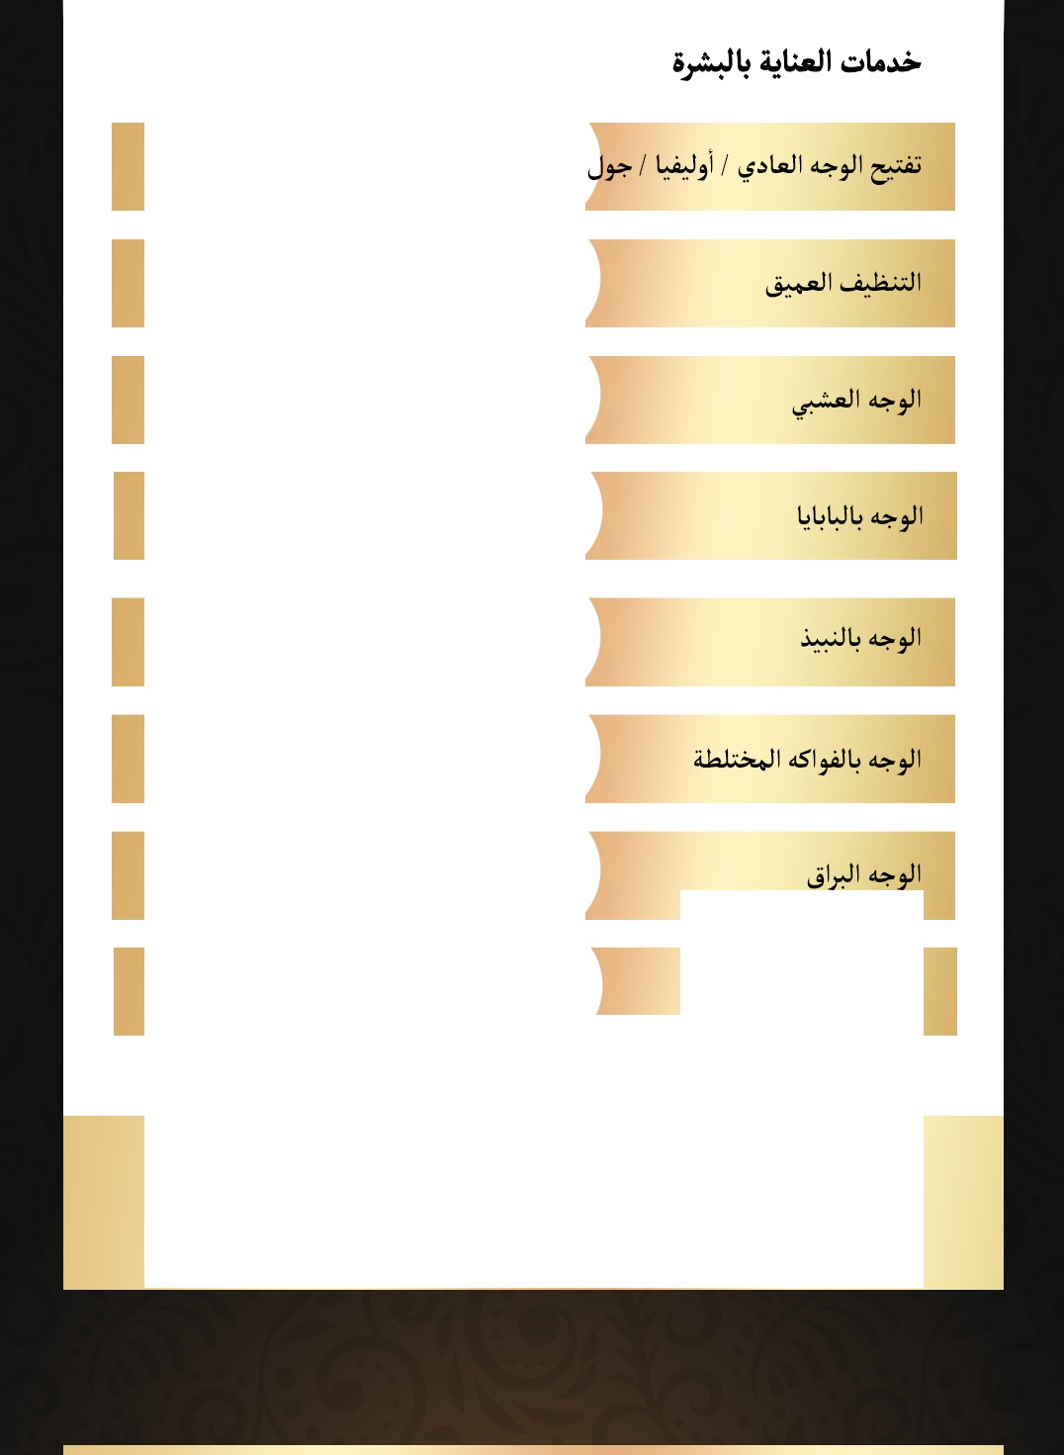

**CallUs:0522381623** / **624** / **625**

Visit [www.ygsalon.ae](http://www.ygsalon.ae/)for more information and to book an appointment